**ABSTRACT**

The project entitled as **“QR Code Based Hall ticket System for Students”** has developed using JAVA as front end and My SQL server as back end. This project is being created to decrease the effort of human and forgery in hall tickets in the educational institutes. The hall ticket is fully based on the Quick Response (QR) code, which is a new embedding technique. This project is the pure automated solution and it will help to generate student hall ticket easily. It is a special type of software which will be used to make a secure hall ticket with QR code instead of the bar code

In current scenario, educational institutes have different types of examinations. For all these they need to distribute hall ticket. In the existing system, there are printed hall tickets are used. So any one can forge and make malpractice over the printed copies. The main aim of this project to generate unique QR code for students’ hall tickets. This helps to keep the data secret. Using the QR reader/scanner the hall ticket information’s can be extracted. Using this application, the admin can generate hall ticket for individual students; this will be transferred via email.

The students can take printout of these QR codes at the time of examination. In this automated system the hall ticket and results data generation process is completely done by the computer with the help of the software.

## CHAPTER 1

**INTRODUCTION**

**1.1 OVERVIEW OF THE PROJECT**

The project entitled as **“QR Code Based Hall ticket System for Students”** has developed using JAVA as front end and My SQL server as back end. This project is being created to decrease the effort of human and forgery in hall tickets in the educational institutes. The hall ticket is fully based on the Quick Response (QR) code, which is a new embedding technique. This project is the pure automated solution and it will help to generate student hall ticket easily. It is a special type of software which will be used to make a secure hall ticket with QR code instead of the bar code

In current scenario, educational institutes have different types of examinations. For all these they need to distribute hall ticket. In the existing system, there are printed hall tickets are used. So any one can forge and make malpractice over the printed copies. The main aim of this project to generate unique QR code for students’ hall tickets. This helps to keep the data secret. Using the QR reader/scanner the hall ticket information’s can be extracted. Using this application, the admin can generate hall ticket for individual students; this will be transferred via email.

The students can take printout of these QR codes at the time of examination. In this automated system the hall ticket and results data generation process is completely done by the computer with the help of the software.

## CHAPTER 2

**SYSTEM ANALYSIS**

* 1. **EXISTING SYSTEM**

In existing system there will be order form (or) letter which is registered or updated by the employee of an Organization. The customer has to visit the office whenever they have any booking regarding the services, which is time consuming process. The registered booking may be forwarded to the workers in the specified department.

## Drawbacks of Existing System

The following are the drawbacks of the existing system

* + - In Cargo management system, the process is done manually.
    - Due to that they face problems like data loss.
    - It consumes more time to process the bookings.
    - The customer does not know current location of the product.

## PROPOSED SYSTEM

Previously, In Cargo Management system they were done manual. Now developed the site to make the things computerized. The customer can submit the orders through the website. The submitted orders are assigned to the workers for further action. The orders can be tracked by the users. The system is a web enabled centralized information and management application to meet customer requirements in building best relations with its public community by providing fast mechanism to the customer grievances. The website will collect more information from the user and give a better view to the booking of cargoes.

After made booking it will be stored in the database. The user can view the booking of cargo in their Account and also able to track the live location of the cargo. The customer can also view the past booking in the website. The status of order is sent periodically through E-Mail.

## Advantages of Proposed System

The following are the advantage of proposed system

* + - Data is maintained in a structured format.
    - Reliable Customer Order Process.
    - User can view the location of orders.

## FEASIBILITY STUDY

The feasibility of the system is analyzed in this phase and business proposal is put forth with general plan for the project and cost estimates. During the system analysis of the project, the feasibility study of proposed system is to be carried out. For feasibility analysis, some understanding of the major requirements for the system is essential. Three key considerations involved in feasibility analysis are

* + - Technical Feasibility
    - Economic Feasibility
    - Operational Feasibility

## Technical Feasibility

Technical feasibility assesses the current resources (such as hardware and software) technology, which are required to accomplish user requirements in the software within the allocated time and budget. For this, whether the certain current resources and technology can be upgraded or added in the software to accomplish specified user requirements.

The technical requirements of the application are simple and basic. Python is used for the developers of the application and the framework is largely used by many, thus there will be enough support for future enhancements. The framework is stable and the support from the developers is constantly updated. The devices which have internet connectivity are enough for the application.

## Economic Feasibility

Economic feasibility determines whether the required software is capable of generating financial gains for an organization. It involves the cost incurred on the software development team, estimated cost of hardware and software, cost of performing feasibility study, and so on.

The cost of application development is very less and the cost of implementation is also less. It can be developed with the system with minimum requirements and can also be operated with the system with some basic requirements that are available the existing systems. For this, it is essential to consider expenses made on purchases and activities required to carry out software development.

## Operational Feasibility

Operational feasibility assesses the extent to which the required software performs a series of steps to solve user requirements. This feasibility is dependent on developer and involves visualizing whether the software will operate after it has been developed and be operative.

The application is developed based on the user requirements and is developed on the priority of the user requirements such as an integrated service and reviewing platform.

## PROBLEM ANALYSIS

The orders from public are submitted through email, letter or form to the corresponding authority. The registered orders are forwarded to corresponding authority and report about the orders is submitted. The status of orders addressed is not recorded and maintained properly. The maps are not implemented. So, the customer does not know live location of the package. There is need for the software which receives the orders through online, forwarded to respective peoples for rectification and post the status of orders.

## CONTEXT AND DATA FLOW DIAGRAM

A data-flow diagram (DFD) is a way of representing a flow of a data of a process or system. The DFD also provides information about the outputs and inputs of each entity and process itself. A data-flow diagram is a part of structured-analysis modelling tools.

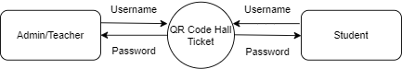

**LEVEL 1:**

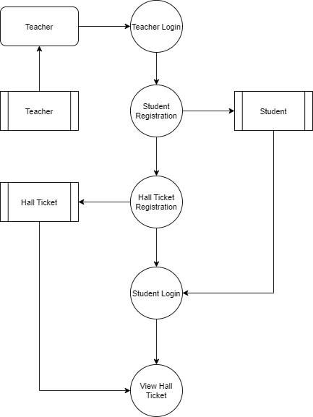

* 1. **SYSTEM CONFIGURATION**

### Hardware Requirements

Processor : Intel Core i5 RAM Capacity : 4 GB

Hard Disk : 120 GB

### Software Requirements

Operating System: Windows 8,10 Ultimate Front End : HTML AND CSS

Server used : MYSQL

Back End : JAVA

### Software Descriptions HTML

Hypertext Markup Language (HTML) is the standard [markup language](https://en.wikipedia.org/wiki/Markup_language) for creating [web pages](https://en.wikipedia.org/wiki/Web_page) and [web applications](https://en.wikipedia.org/wiki/Web_application). With [Cascading Style Sheets](https://en.wikipedia.org/wiki/Cascading_Style_Sheets) (CSS) and [JavaScript](https://en.wikipedia.org/wiki/JavaScript) it forms a triad of cornerstone technologies for the [World Wide Web.](https://en.wikipedia.org/wiki/World_Wide_Web) [Web](https://en.wikipedia.org/wiki/Web_browser) [browsers](https://en.wikipedia.org/wiki/Web_browser) receive HTML documents from a [web server](https://en.wikipedia.org/wiki/Web_server) or from local storage and render them into multimedia web pages. HTML describes the structure of a web page [semantically](https://en.wikipedia.org/wiki/Semantic_Web) and originally included cues for the appearance of the document.

[HTML elements](https://en.wikipedia.org/wiki/HTML_element) are the building blocks of HTML pages. With HTML constructs, [images](https://en.wikipedia.org/wiki/HTML_element#Images_and_objects) and other objects, such as [interactive forms,](https://en.wikipedia.org/wiki/Fieldset) may be embedded into the rendered page. It provides a means to create [structured documents](https://en.wikipedia.org/wiki/Structured_document) by denoting structural [semantics](https://en.wikipedia.org/wiki/Semantics) for text such as headings, paragraphs, lists, [links,](https://en.wikipedia.org/wiki/Hyperlink) and other items.

HTML elements are delineated by *tags*, written using [angle brackets](https://en.wikipedia.org/wiki/Bracket#Angle_brackets). Tags such as,

<img /> and <input /> introduce content into the page directly. Others such as <p>...</p> surround and provide information about document text and may include other tags as sub-elements. Browsers do not display the HTML tags, but use them to interpret the content of the page.

HTML can embed programs written in a [scripting language](https://en.wikipedia.org/wiki/Scripting_language) such as [JavaScript](https://en.wikipedia.org/wiki/JavaScript) which affect the behavior and content of web pages. Inclusion of CSS defines the look and layout of content. These are designed to be usable by all Open Web developers, this reference page links to numerous resources about HTML5 technologies, classified into several groups based on their function.

### CSS

Cascading Style Sheets (CSS) is a [style sheet language](https://en.wikipedia.org/wiki/Style_sheet_language) used for describing the [presentation](https://en.wikipedia.org/wiki/Presentation_semantics) of a document written in a [mark-up language](https://en.wikipedia.org/wiki/Markup_language). Although most often used to set the visual style of [web pages](https://en.wikipedia.org/wiki/Web_page) and user interfaces written in [HTML](https://en.wikipedia.org/wiki/HTML) and [XHTML,](https://en.wikipedia.org/wiki/XHTML) the language can be applied to any [XML](https://en.wikipedia.org/wiki/XML) document, including [plain XML,](https://en.wikipedia.org/wiki/Plain_Old_XML) [SVG](https://en.wikipedia.org/wiki/Scalable_Vector_Graphics) and [XUL,](https://en.wikipedia.org/wiki/XUL) and is applicable to rendering in [speech,](https://en.wikipedia.org/wiki/Speech_synthesis) or on other media. Along with HTML and [JavaScript](https://en.wikipedia.org/wiki/JavaScript), CSS is a cornerstone technology used by most websites to create visually engaging web pages, user interfaces for [web applications](https://en.wikipedia.org/wiki/Web_applications), and user interfaces for many mobile applications.

CSS is designed primarily to enable the separation of presentation and content, including aspects such as the [layout](https://en.wikipedia.org/wiki/Page_layout), [colors](https://en.wikipedia.org/wiki/Color), and [fonts](https://en.wikipedia.org/wiki/Typeface). This separation can improve content [accessibility,](https://en.wikipedia.org/wiki/Accessibility) provide more flexibility and control in the specification of presentation characteristics, enable multiple HTML pages to share formatting by specifying the relevant CSS.

### Java

Java is a high-level programming language developed by Sun Microsystems. It was originally designed for developing programs for set-top boxes and handheld devices, but later became a popular choice for creating web applications.

The Java syntax is similar to C++, but is strictly an object-oriented programming language. For example, most Java programs contain classes, which are used to define objects, and methods, which are assigned to individual classes. Java is also known for being more strict than C++, meaning variables and functions must be explicitly defined. This means Java source code may produce errors or "exceptions" more easily than other languages, but it also limits other types of errors that may be caused by undefined variables or unassigned types.

Unlike Windows executables (.EXE files) or Macintosh applications (.APP files), Java programs are not run directly by the operating system. Instead, Java programs are interpreted by the Java Virtual Machine, or JVM, which runs on multiple platforms. This means all Java programs are multiplatform and can run on different platforms, including Macintosh, Windows, and Unix computers. However, the JVM must be installed for Java applications or applets to run at all. Fortunately, the JVM is included as part of the Java Runtime Environment (JRE),

### MySQL

MySQL is the popular Open Source Relational SQL Database Management System. MySQL is being used for developing various web-based software applications. The MySQL development project has made its [source code](https://en.wikipedia.org/wiki/Source_code) available under the terms of the [General Public](https://en.wikipedia.org/wiki/GNU_General_Public_License) [License.](https://en.wikipedia.org/wiki/GNU_General_Public_License) It is used to store the information.

MySQL was owned and sponsored by the single for-profit firm, the Swedish company MySQL AB, now owned by Oracle Corporation. For proprietary use, several paid editions are available, and offer additional functionality.

## CHAPTER 3

**SYSTEM DESIGN**

### INPUT DESIGN

Input Design is the process of converting a user-oriented description of the input into a computer-based system. The goal of designing input is to make data entry easier and to be free from errors. The data entry screen is designed in such a way that all the data manipulates can be performed. Input Design is the first phase in the system design. Input designing is to converting the user-oriented information to the computer- oriented form. The input data items are grouped and analyzed to find out whether the proposed system can be developed from the user input. The system is developed using various processes screens formats.

The main objective of input design is to

* + - It should serve specific purpose effectively such as storing, recording, and retrieving the information.
    - It ensures proper completion with accuracy.
    - It should be easy to fill and straightforward.
    - It should focus on user’s attention, consistency and simplicity.

### DATABASE DESIGN

The most important consideration in designing the database is how the information will be used. The main objective of designing a database is Data Integration, Data Integrity and Data Independence.

### Data Integration

In a database, information from several files are coordinated, accessed and operated upon as through it is in a single file. Logically, the information is centralized, physically, the data may be located on different devices, connected through data communication facilities.

### Data Integrity

Data integrity means storing all data in one place only and how each application access it. This approach results in more consistent information, one update being sufficient to achieve a new record status for all applications. This leads to less data redundancy, that is data items need not be duplicated. A reduction in the direct access storage requirement.

### Data Independence

Data independence is the insulation of application programs from changing aspects of physical data organization. This objective seeks to allow changes in the content and organization of physical data without reprogramming of application and allow modifications to application programs without reorganizing the physical data.

### 3.2.1 TABLE DESIGN

The table needed for each module were designed and the specification of each and every column was given based on the records and details collected during record specification of the system study.

### Table 3.1 Admin

|  |  |  |  |
| --- | --- | --- | --- |
| **FIELD NAME** | **FIELD TYPE** | **SIZE** | **CONSTRAINT** |
| Id | Int | 10 | PRIMARY KEY |
| Username | Varchar | 15 | Not null |
| Password | Varchar | 20 | Not null |

**Table 3.2 Student**

|  |  |  |  |
| --- | --- | --- | --- |
| **FIELD NAME** | **FIELD TYPE** | **SIZE** | **CONSTRAINT** |
| Id | Int | 10 | Primary key |
| First_name | Varchar | 15 | Not null |
| Last_name | Varchar | 15 | Not null |
| Roll_no | Varchar | 15 | Not null |
| Department | Varchar | 15 | Not null |
| Classname | Varchar | 15 | Not null |
| Username | Varchar | 15 | Not null |
| Password | Varchar | 15 | Not null |

**Table 3.3 hall ticket**

|  |  |  |  |
| --- | --- | --- | --- |
| **FIELD NAME** | **FIELD TYPE** | **SIZE** | **CONSTRAINT** |
| Id | Int | 10 | Primary key |
| Student_id | Int | 10 | Foreign key |
| Subject | Varchar | 15 | Not null |
| Hallno | Varchar | 15 | Not null |
| Examdate | Date | 10 | Not null |

**Table 3.4 qrcode**

|  |  |  |  |
| --- | --- | --- | --- |
| **FIELD NAME** | **FIELD TYPE** | **SIZE** | **CONSTRAINT** |
| Id | Int | 10 | Primary key |
| Student_id | Int | 10 | Foreign key |
| Hall_ticket_id | Int | 10 | Foreign key |
| Qrcode | Varchar | 30 | Not null |

* 1. **MODULE DESCRIPTION**

The main module in this project are listed below

* + - Teacher/Admin Login
    - Student Registration
    - Hall Ticket Registration
    - QR Code generation
    - Student Login
    - View Hall Ticket

### Teacher/Admin Login

After the student registration have been completed, the admin registered the hall ticket details. This record will be stored in to the hall ticket table. Once the ticket has been registered then the QR code has been generated.

### Student Registration

### 

### This module has been handling by the admin, this module collects the all the information about the student. Once all the fields values have collected then can register it. These values have been stored in to the student table.

### Hall Ticket Registration

### After the student registration have been completed, the admin registered the hall ticket details. This record will be stored in to the hall ticket table. Once the ticket has been registered then the QR code has been generated.

### QR Code Generation

QR Code will be generated and viewed into the server, when student login into the application it will can show into the hall ticket details screen.

### Student Login

Once the student registration has been completed, then they have unique username and password. Which fields are collect the information from the student table. If the username or password is incorrect, we won’t allow to enter into the application.

### View Hall Ticket

Student can able to view the hall ticket as a QR code. When student reached the exam hall the teachers scanning the QR code view the student details accordingly.

## CHAPTER 4 SYSTEM TESTING

Testing is an integral part of any system development life cycle. Insufficient and untested applications may tend to crash and the result is loss of economic and manpower investment besides user's dissatisfaction and downfall of reputation. Software testing can be looked upon as one among many processes, an organization performs, and that provides the lost opportunity to correct any flaws in the developed system. Software testing includes selecting test data that have more probability of giving errors.

The first step in system testing is to develop a plan that tests all aspects of the system. Completeness, correctness, reliability and maintainability of the software are to be tested for the best quality assurance that the system meets the specification and requirements for its intended use and performance. System testing is the most useful practical process of executing a program with the implicit intention of finding errors that make the program fails. System testing is done in three phases.

* + - * Unit Testing
      * Integration Testing
      * Validation Testing

### UNIT TESTING

Unit testing focuses verification effort on the smallest unit of software the module. Using the detailed design and the process specification testing is done to registration by the user with in the boundary of the Login module. The login form receives the username and password details and validates the value with the database. If valid, the home page is displayed.

### INTEGRATION TESTING

Integration Testing is the process of this activity can be considered as testing the design and hence module interaction. The primary objective of integration testing is to discover errors in the interfaces between the components. Login form and registration form are integrated and tested together. If the user is newly registered, the received details will be stored in the registration table. While logging in, the application will check for valid user name and password in the registration table and if valid the user is prompted for submitting complaints.

### VALIDATION TESTING

Validation are independent procedures that are used together for checking that a product, service, or system meets [requirements](https://en.wikipedia.org/wiki/Requirement) and [specifications](https://en.wikipedia.org/wiki/Specification_(technical_standard)) and that it fulfills its in purpose the actual result from the expected result for the complaint process. Select the complaint category of the complaint by user. The input given to various forms fields are validated effectively. Each module is tested independently. It is tested that the complaint module fields receive the correct input for the necessary details such as complaint category, complaint id, reference name, complaint description, email for further process.

## CHAPTER 5

* 1. **CONCLUSION**

QR code has many applications as can imagine. In this paper, we have utilized the versatility of QR code in implementing functional and provide the exam hall plan details in an efficient manner. This project helps the user to know the exam details of the respective subjects in a less time and faster. We can add more details about the respective individuals in the future.

The implementations and features made in the QR Code System are as follows,

* + - Very user-friendly.
    - Easy accessibility to view the order status.
    - Improves data maintenance.

## APPENDICES APPENDIX I SAMPLE CODE

### Home Page

<html>

<head>

<link rel="stylesheet" href="./style.css" />

<script src="https://ajax.googleapis.com/ajax/libs/jquery/1.10.2/jquery.min.js"></script>

<link rel="stylesheet" href="https://maxcdn.bootstrapcdn.com/bootstrap/4.0.0/css/bootstrap.min.css"

integrity="sha384-Gn5384xqQ1aoWXA+058RXPxPg6fy4IWvTNh0E263XmFcJlSAwiGgFAW/dAiS6JXm" crossorigin="anonymous">

<script src="https://maxcdn.bootstrapcdn.com/bootstrap/4.0.0/js/bootstrap.min.js"

integrity="sha384-JZR6Spejh4U02d8jOt6vLEHfe/JQGiRRSQQxSfFWpi1MquVdAyjUar5+76PVCmYl"

crossorigin="anonymous"></script>

<script type="text/javascript" src="qrcode.js"></script>

<style>

.qrcode {

width:160px;

height:160px;

margin-top:15px;

}

</style>

</head>

<body class="bodys">

<div data-tabs class="tabs">

<div class="tab">

<input type="radio" name="tabgroup" id="tab-1" checked>

<label for="tab-1">Student Registration</label>

<div class="tab__content">

<div class="form-group">

<label>First Name</label>

<input id="one" class="form-control" id="exampleInputPassword1">

</div>

<div class="form-group">

<label>Last Name</label>

<input id="two" class="form-control" id="exampleInputPassword1">

</div>

<div class="form-group">

<label>Roll No</label>

<input id="three" class="form-control" id="exampleInputPassword1">

</div>

<div class="form-group">

<label>Department</label>

<input id="four" class="form-control" id="exampleInputPassword1">

</div>

<div class="form-group">

<label>Class Name</label>

<input id="five" class="form-control" id="exampleInputPassword1">

</div>

<div class="form-group">

<label>Username</label>

<input id="six" class="form-control" id="exampleInputPassword1">

</div>

<div class="form-group">

<label>Password</label>

<input id="seven" class="form-control" id="exampleInputPassword1">

</div>

<button id="student_register" type="submit" class="btn btn-primary">Regiter Student</button>

</div>

</div>

<div class="tab">

<input type="radio" name="tabgroup" id="tab-2">

<label for="tab-2">Hall Ticket Registration</label>

<div class="tab__content">

<div class="form-group">

<label>Roll No</label>

<input id="one2" class="form-control" id="exampleInputPassword1">

</div>

<div class="form-group">

<label>Subject Name</label>

<input id="two2" class="form-control" id="exampleInputPassword1">

</div>

<div class="form-group">

<label>Exam Hall No</label>

<input id="three2" class="form-control" id="exampleInputPassword1">

</div>

<div class="form-group">

<label>Exam Date</label>

<input id="four2" class="form-control" id="exampleInputPassword1">

</div>

<button id="add_hallticket" type="submit" class="btn btn-primary">Create Member</button>

</div>

</div>

<div class="tab">

<input type="radio" name="tabgroup" id="tab-3">

<label for="tab-3">View Hall Tickets</label>

<div class="tab__content">

<table class="table table-bordered">

<thead>

<tr>

<th scope="col">#</th>

<th scope="col">Roll No</th>

<th scope="col">Student Name</th>

<th scope="col">Hall Ticket Number</th>

<th scope="col">QR Code</th>

</tr>

</thead>

<tbody id="ticket_body">

<tr>

<th scope="row">1</th>

<td>xxxxx</td>

<td>xxxxx</td>

<td>xxxxx</td>

</tr>

</tbody>

</table>

</div>

</div>

<div class="tab">

<input type="radio" name="tabgroup" id="tab-4">

<label for="tab-4">Logout</label>

</div>

</div>

</body>

<script>

(function ($, document) {

// get tallest tab__content element

let height = -1;

$('.tab__content').each(function () {

height = height > $(this).outerHeight() ? height : $(this).outerHeight();

$(this).css('position', 'absolute');

});

// set height of tabs + top offset

$('[data-tabs]').css('min-height', height + 40 + 'px');

}(jQuery, document));

</script>

<script src="./admin-home.js"></script>

</html>

$(document).ready(function () {

getTickets();

getTicket();

$("#student_register").on('click', function () {

var one = $("#one").val();

var two = $("#two").val();

var three = $("#three").val();

var four = $("#four").val();

var five = $("#five").val();

var six = $("#six").val();

var seven = $("#seven").val();

$.ajax({

type: "GET",

url: "http://localhost:8080/api/add_student/" + one + "/" + two+ "/" + three+ "/" + four+ "/" + five+ "/" + six+ "/" + seven

}).done(function (data) {

$("#one").val("");

$("#two").val("");

$("#three").val("");

$("#four").val("");

$("#five").val("");

$("#six").val("");

$("#seven").val("");

alert(data);

getTickets();

});

});

$("#add_hallticket").on('click', function () {

var one = $("#one2").val();

var two = $("#two2").val();

var three = $("#three2").val();

var four = $("#four2").val();

$.ajax({

type: "GET",

url: "http://localhost:8080/api/add_hallticket/" + one + "/" + two+ "/" + three+ "/" + four

}).done(function (data) {

$("#one").val("");

$("#two").val("");

$("#three").val("");

$("#four").val("");

alert(data);

getTickets();

});

})

});

function makeCode (id,value) {

return id.makeCode(value );

}

function getTicket(){

const queryString = window.location.search;

const urlParams = new URLSearchParams(queryString);

const id = urlParams.get('id')

$.ajax({

type: "GET",

url: "http://localhost:8080/api/get_ticket/"+id

}).done(function (data) {

var html='';

for(var i=0;i<data.length;i++){

var row=data[i];

html += ` <div class="card col-md-3" style="width: 18rem;padding:20px">

<div id="qrimage`+i+`" class="card-img-top" src="..." alt="Card image cap">

<div class="card-body">

<p class="card-text">`+data[i][4]+`</p>

</div>

</div></div>`;

}

$("#student_body").html(html);

for(var i=0;i<data.length;i++){

new QRCode(document.getElementById("qrimage"+i), {

width : 100,

height : 100

}).makeCode("Hall Ticlet No:"+data[i][3]+" Roll No:"+data[i][0]+" Student Name:"+data[i][1]);

}

});

}

function getTickets(){

$.ajax({

type: "GET",

url: "http://localhost:8080/api/get_tickets"

}).done(function (data) {

var html='';

for(var i=0;i<data.length;i++){

var row=data[i];

html += `<tr>

<th>`+(i+1)+`</th>

<td>`+row[0]+`</td>

<td>`+row[1]+`</td>

<td>`+row[3]+`</td>

<td><div class="qrcode" id="qrcode`+i+`" style="width:100px; height:100px; margin-top:15px;"></div></td>

</tr>`;

}

$("#ticket_body").html(html);

for(var i=0;i<data.length;i++){

new QRCode(document.getElementById("qrcode"+i), {

width : 100,

height : 100

}).makeCode("Hall Ticlet No:"+data[i][3]+" Roll No:"+data[i][0]+" Student Name:"+data[i][1]);

}

});

}

## APPENDIX II

**SAMPLE SCREENSHOTS**

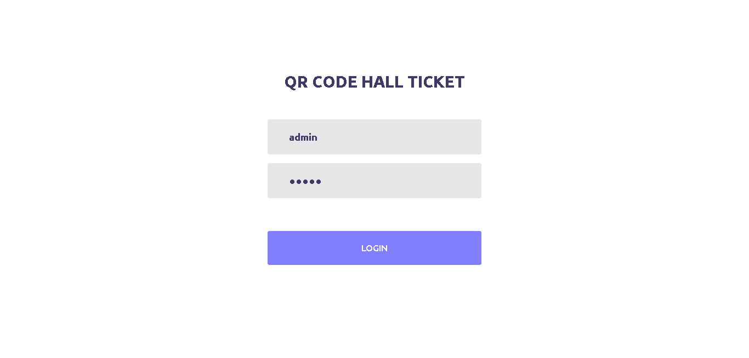

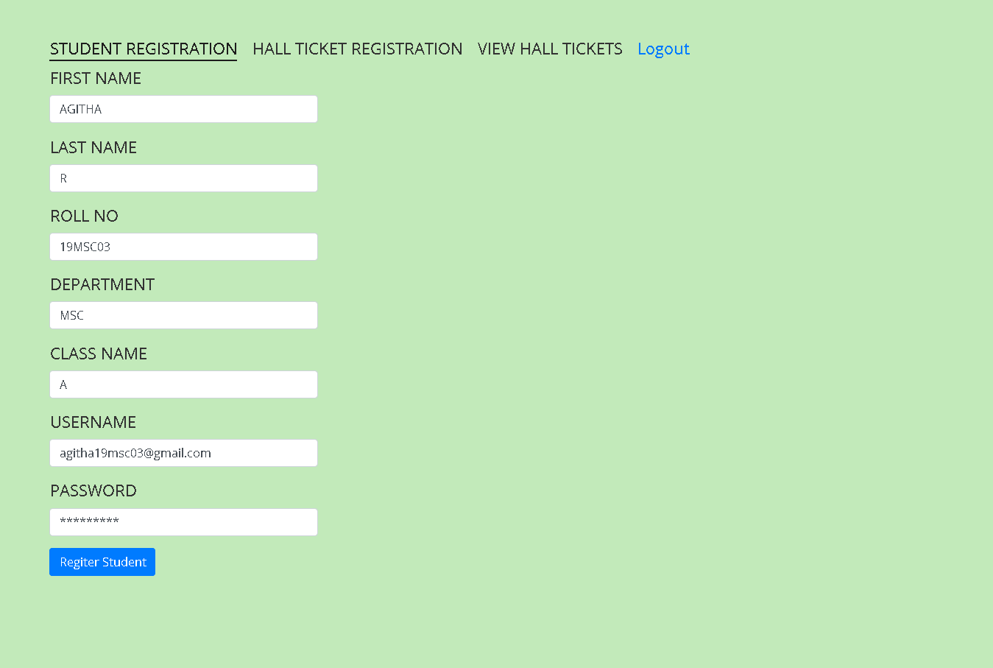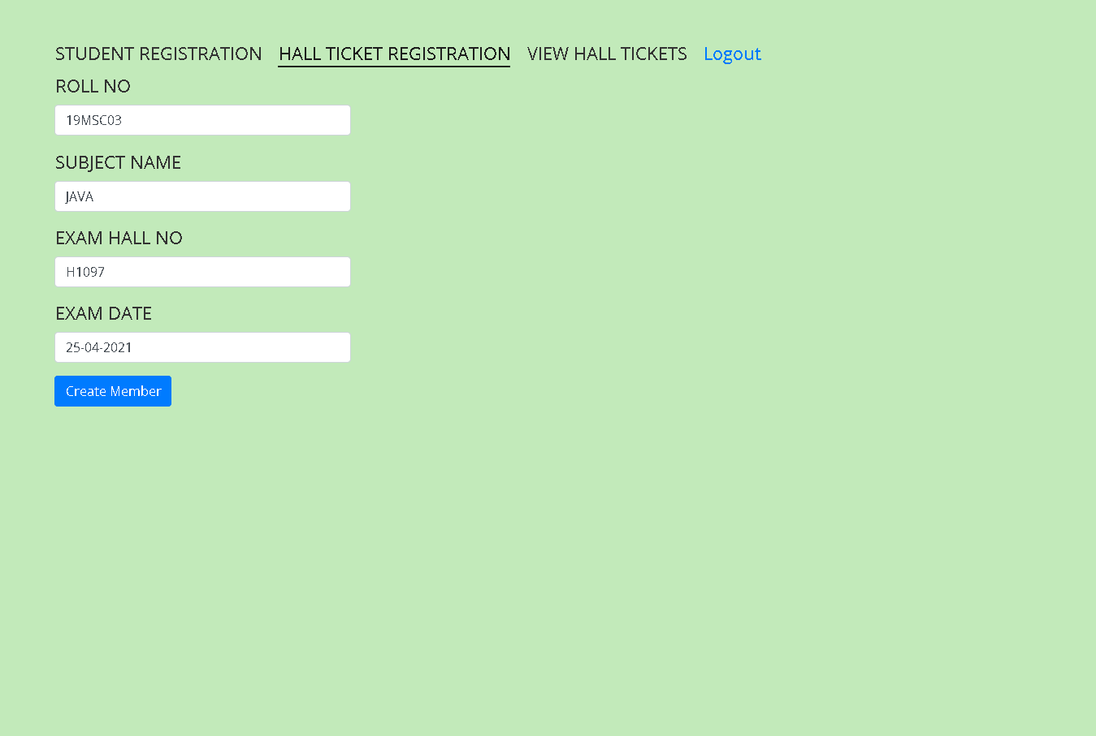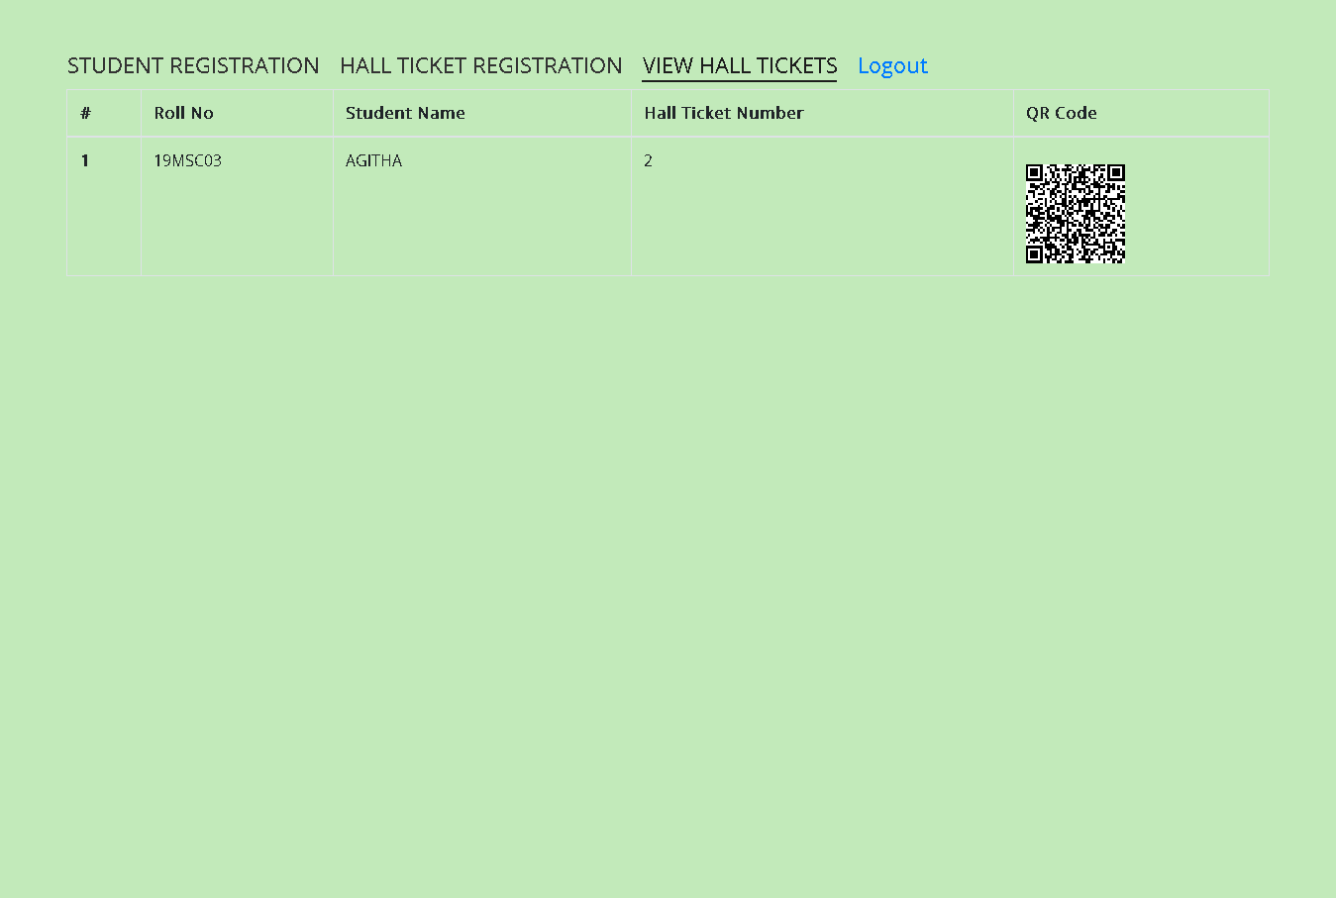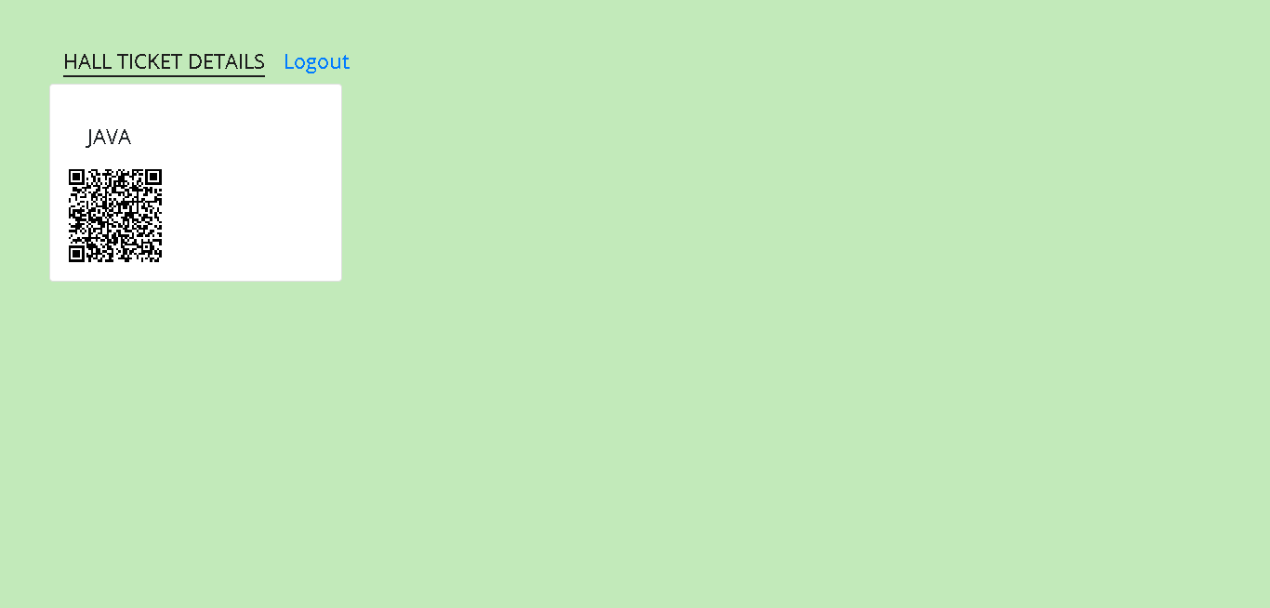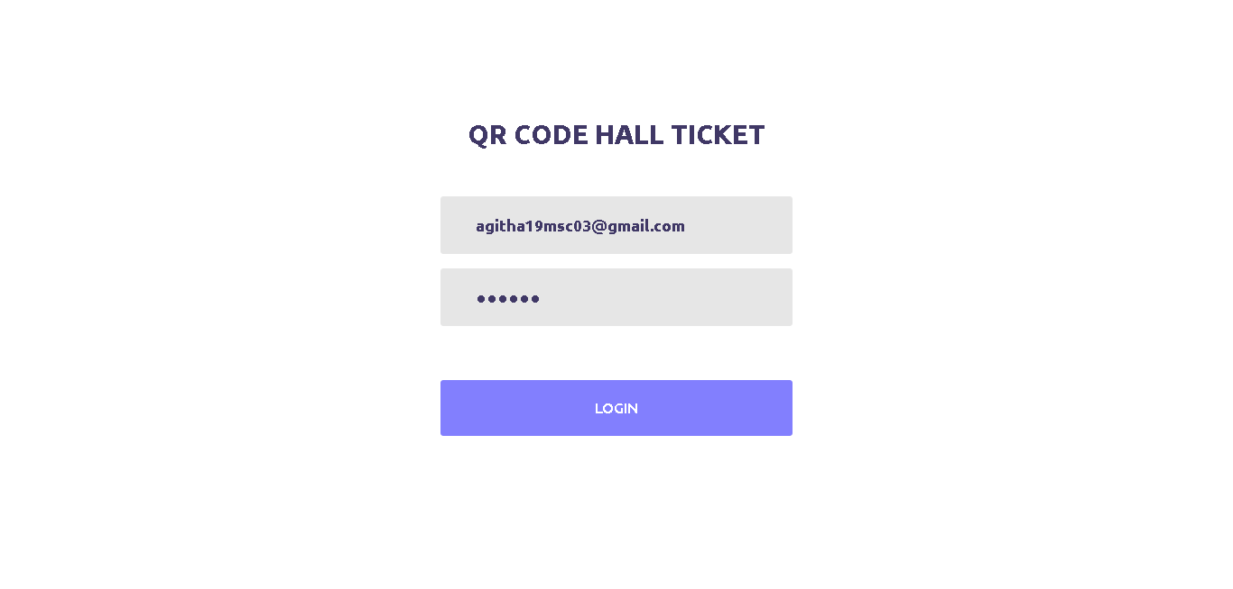

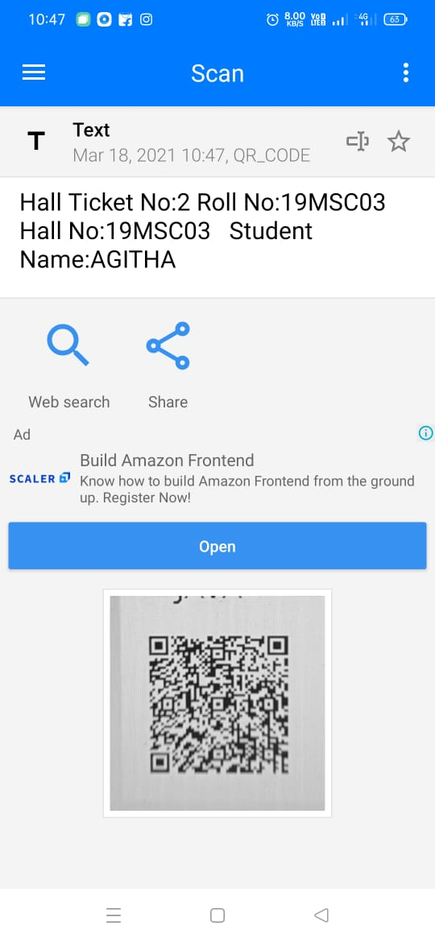

**REFERENCES**

**BOOK REFERENCES**

1. Jeff Forcier, Paul Bissex, Wesley J. Chun, (2018) “Python Web development with Django (Developer’s Library)”, Wesley Professional.
2. Roger S. Pressman, (2017) “Software Engineering”, Tata McGraw-Hill – Europe.
3. William S Vincent, (2018) “Django for Beginners”, Independently published.
4. Gopala Swamy Ramesh*,* Srinivasan Desikan “Software Testing: Principles and Practice”, Pearson Publications.

## WEB REFERENCES

1. https:// [www.pythonprogramming.net](http://www.pythonprogramming.net/)
2. https:// [www.w3schools.com](http://www.w3schools.com/)
3. https:// [www.tutorialspoint.com](http://www.tutorialspoint.com/)